**Chartjunk: what is it & how to get rid of it**

﻿﻿

When we try to make visualization, we tend to think what can can include, instead of thinking about what we can leave out. This gives rise to chartjunk.

Tufte mentions chartjunk in his book[The Visual Display of Quantitative Information (1983)](https://www.edwardtufte.com/tufte/books_vdqi)*.*

**Chartjunk is the excessive and unnecessary use of graphical effects in graphs**.

In simple terms, chartjunk refers to all visual elements that are not necessary for the chart view. For sure, leave out those 3D graphics! But there's more.  
﻿﻿  
﻿﻿  
﻿﻿**Let’s look at an example.**

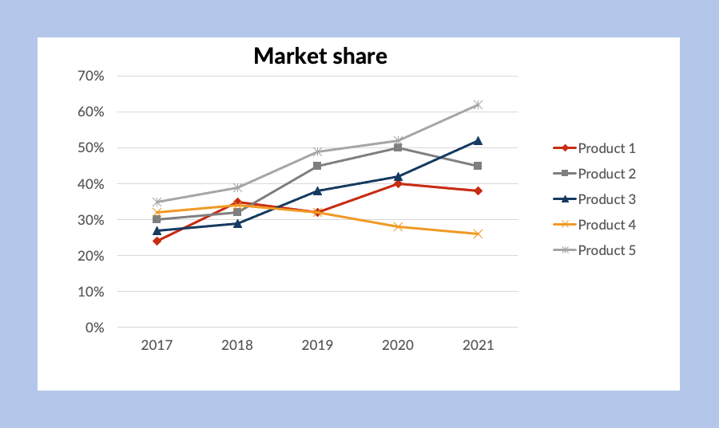﻿﻿

**We can remove:**

1. Gridlines
2. Legend
3. Y-axis.
4. Too many colors

﻿﻿

**Then, we can improve by:**

1. Adding an insightful title
2. Use direct labeling for relevant data
3. Using color only to highlight

﻿﻿

**This is the result:**

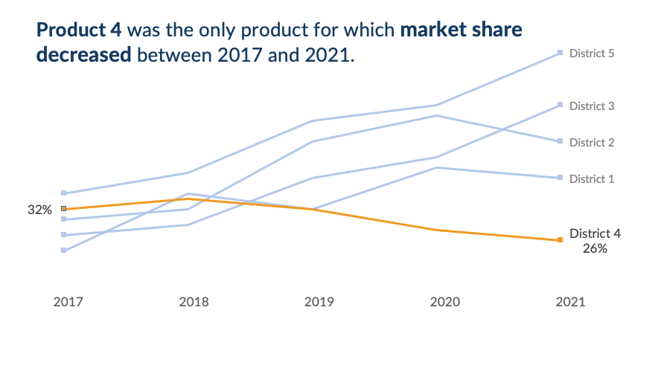

﻿﻿

Thus, adding extra “stuff” is not always informative and it leads to more cognitive load.

Another powerful tool you can use is white space.

﻿﻿

**Why Does White Space Matter In Data Visualization?**

* White space improves readability by ensuring that our graphics and texts are clear and legible.  
  ﻿﻿  
  ﻿﻿
* Effective use of white space has been shown to [improve content comprehension by up to 20 percent](https://www.researchgate.net/publication/220495676_Evaluating_older_adults'_retention_in_hypertext_perusal_Impacts_of_presentation_media_as_a_function_of_text_topology).  
  ﻿﻿  
  ﻿﻿
* White space helps readers understand the content better by creating a sense of order and flow between graphic elements.  
  ﻿﻿  
  ﻿﻿
* It is a creative tool that can help convey a message. See the examples below.



﻿﻿

Credit: [Medium article by Mala Deep](https://towardsdatascience.com/little-known-ways-to-make-your-data-visualization-awesome-890d71b6e365)﻿﻿

﻿﻿

*"White space is to be regarded as an active element, not a passive background"*   
﻿﻿— Jan Tschichold.